# Micro services Architecture -Whole Practice Assignment

**Problem:**

Develop a case study which demonstrates from monolith to micro services which leads to application security, scalability .

**Solution:**

There are 3 Micro Services created.

1. Movie Catalog Service

2. Movie Info Service

3. Rating Data Service

All are deployed in Eureka Server i.e.

4. Discovery Server

1. **Movie Catalog Service :** It will interact with other two micro services and collect the required data.

Movie Catalog Service Application.java:

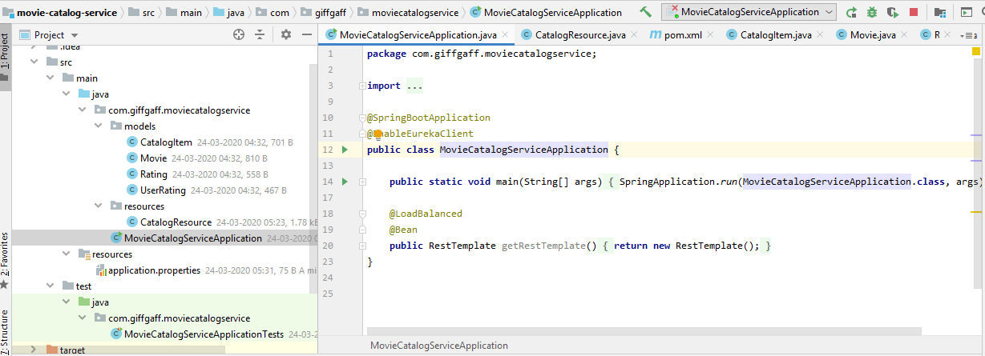

Catalog Service (Rest Controller):

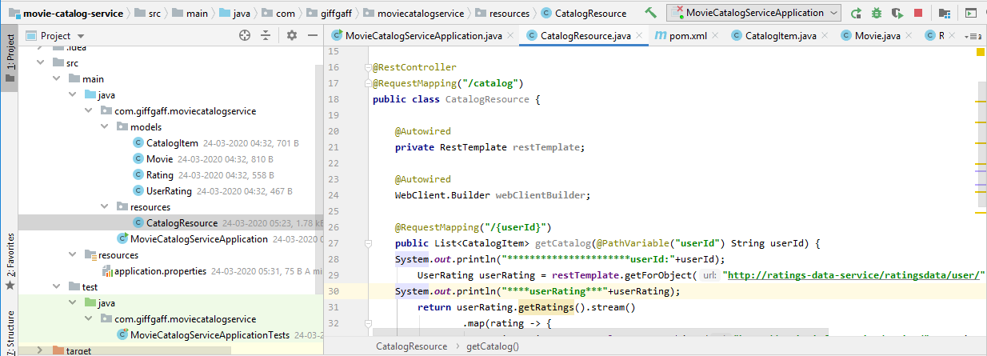

Catalog Item:

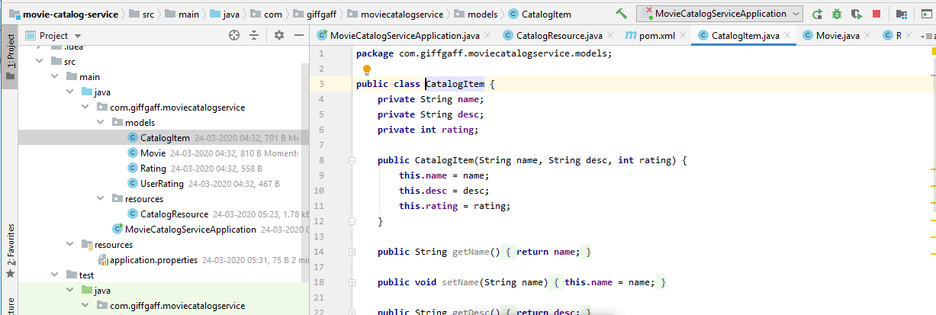

application.properties:

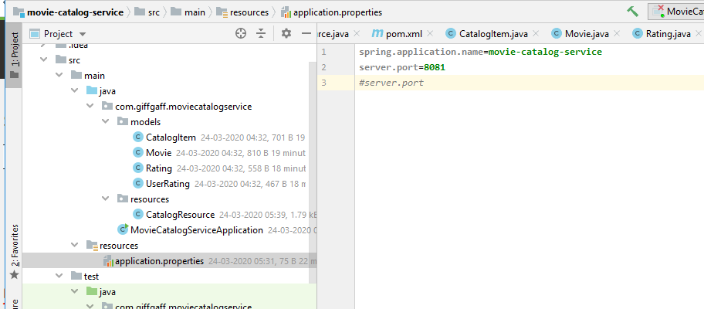

Movie:

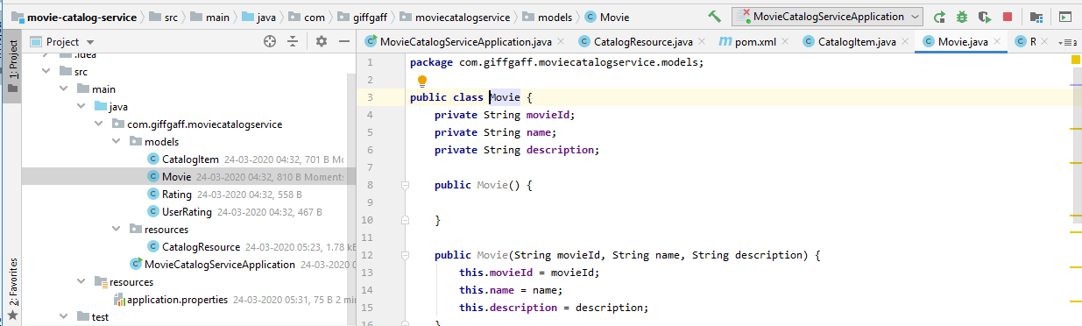

Rating:

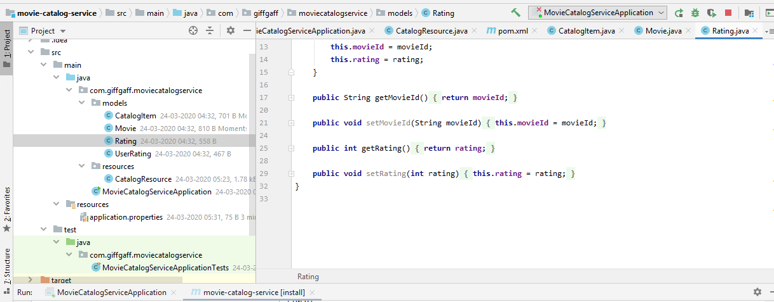

User Rating:

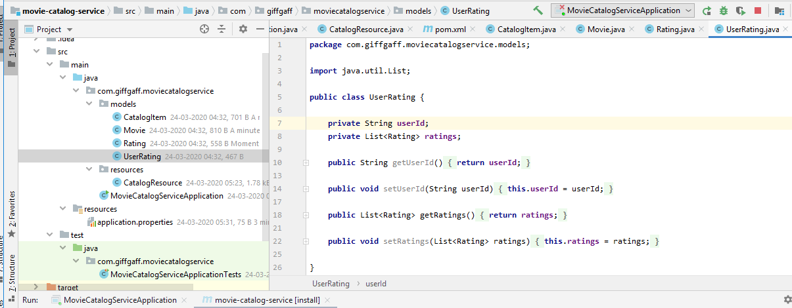

2. Movie Info Service:

Movie Info Service Application:

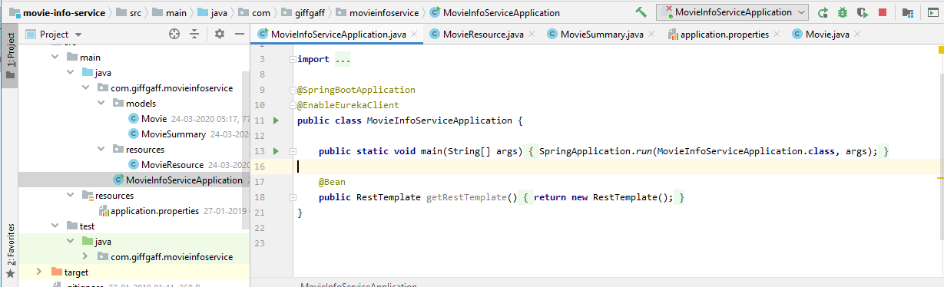

Movie Resource(Request Controller):

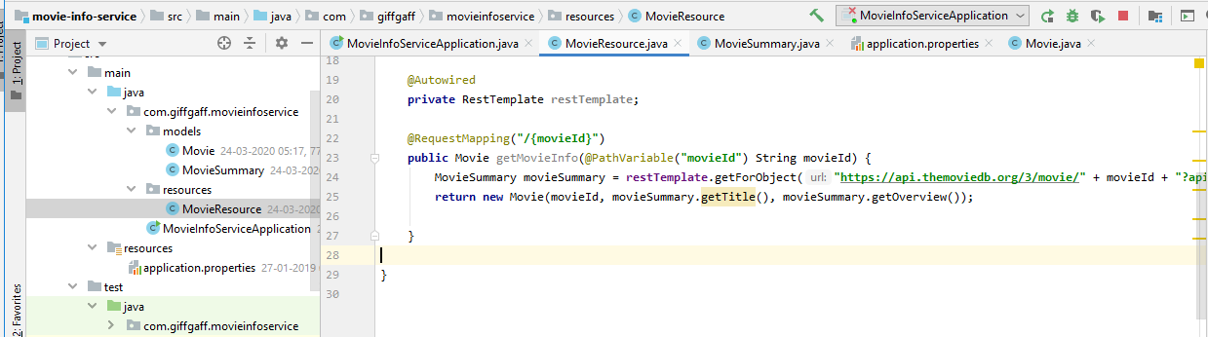

Movie Summary:

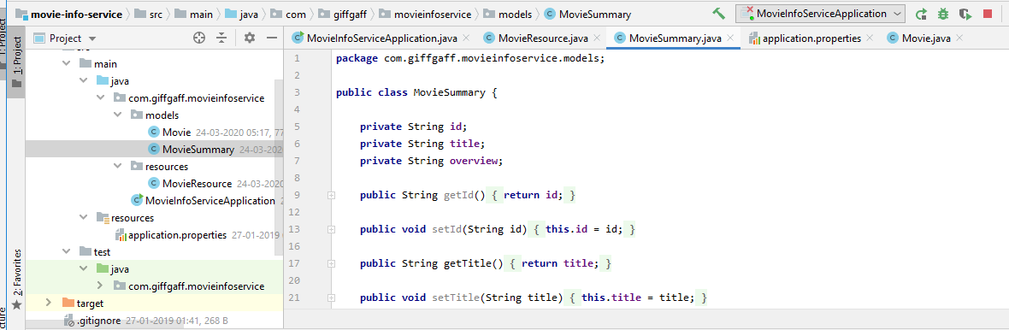

application.properties:

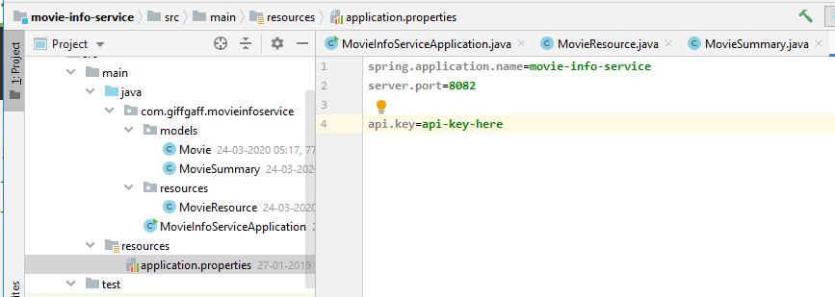

3. Rating Data Service:

Rating Data Service Application:

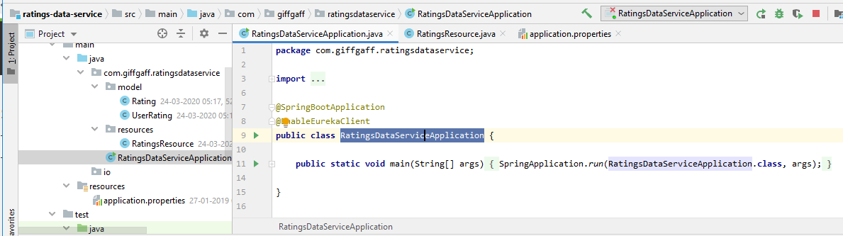

Rating Resource (Request Controller):

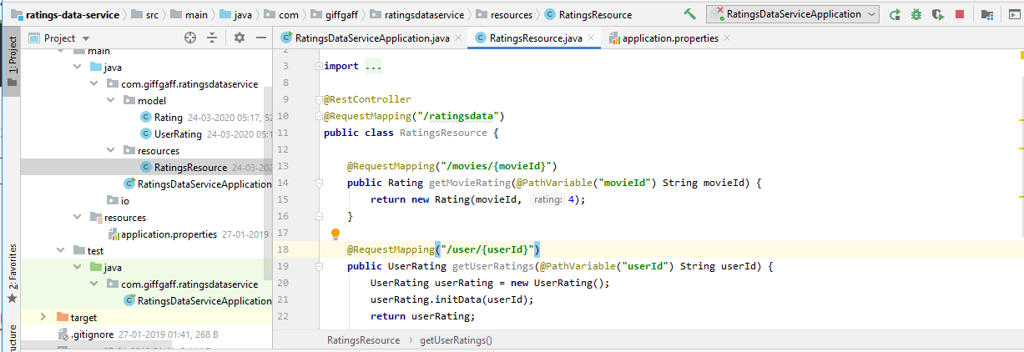

User Rating:

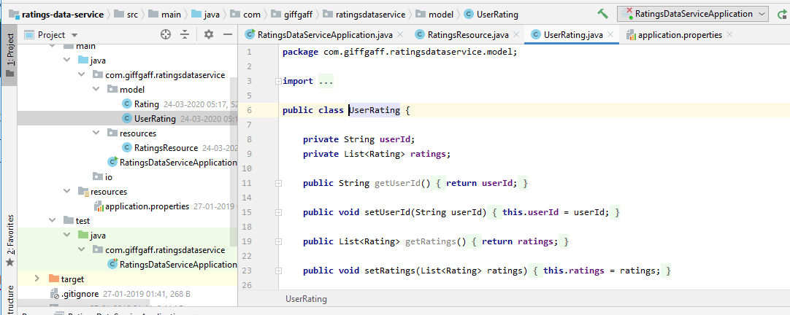

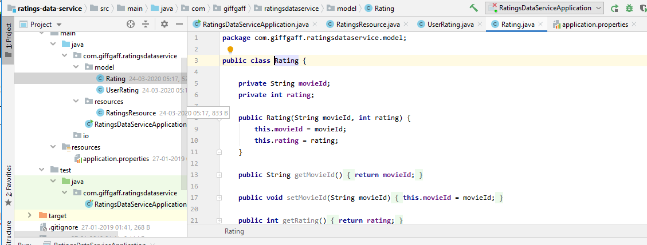

application.properties:

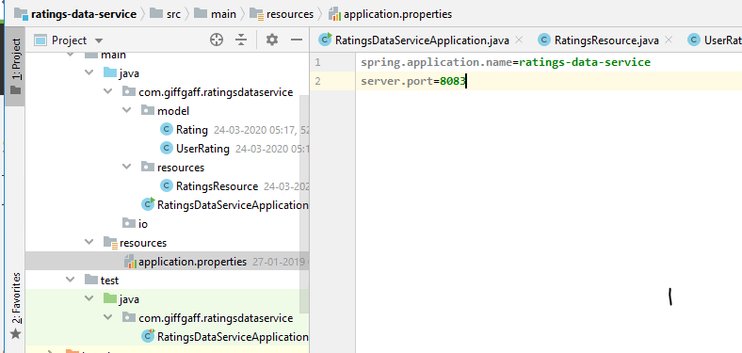

Enable Eureka Server:

4. Discovery Server Application:

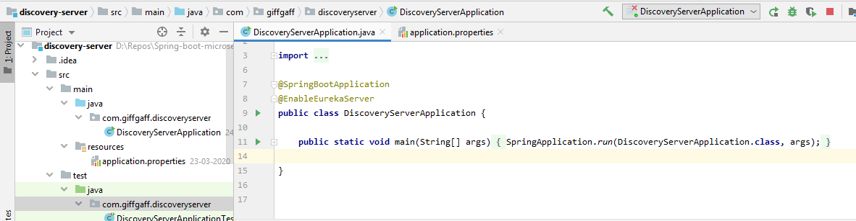

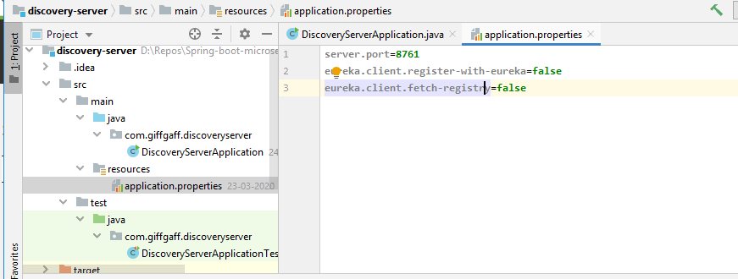

application.properties:

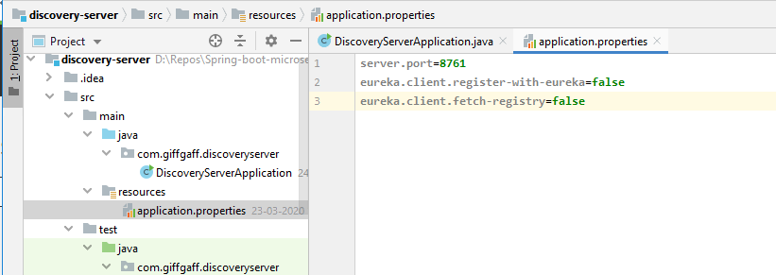

Eureka Server Web Page with deployed all other 3 micro services:

